Revise Online Unit 1 Exams (Depreciation practice)

Log in (with your student email)

reviseonline.com

To do a topic test on Revise Online, select as per the image below, then click Revise and a test will be made for you.

You can do multiple of these tests, they will be different each time. You can start and stop as you wish and you can also go over the suggested time limit. The time limit is to indicate how quickly you will be expected to finish in test conditions. Once you have finished check your answers, for the ledgers ignore columnar answers and just check T-ledgers.

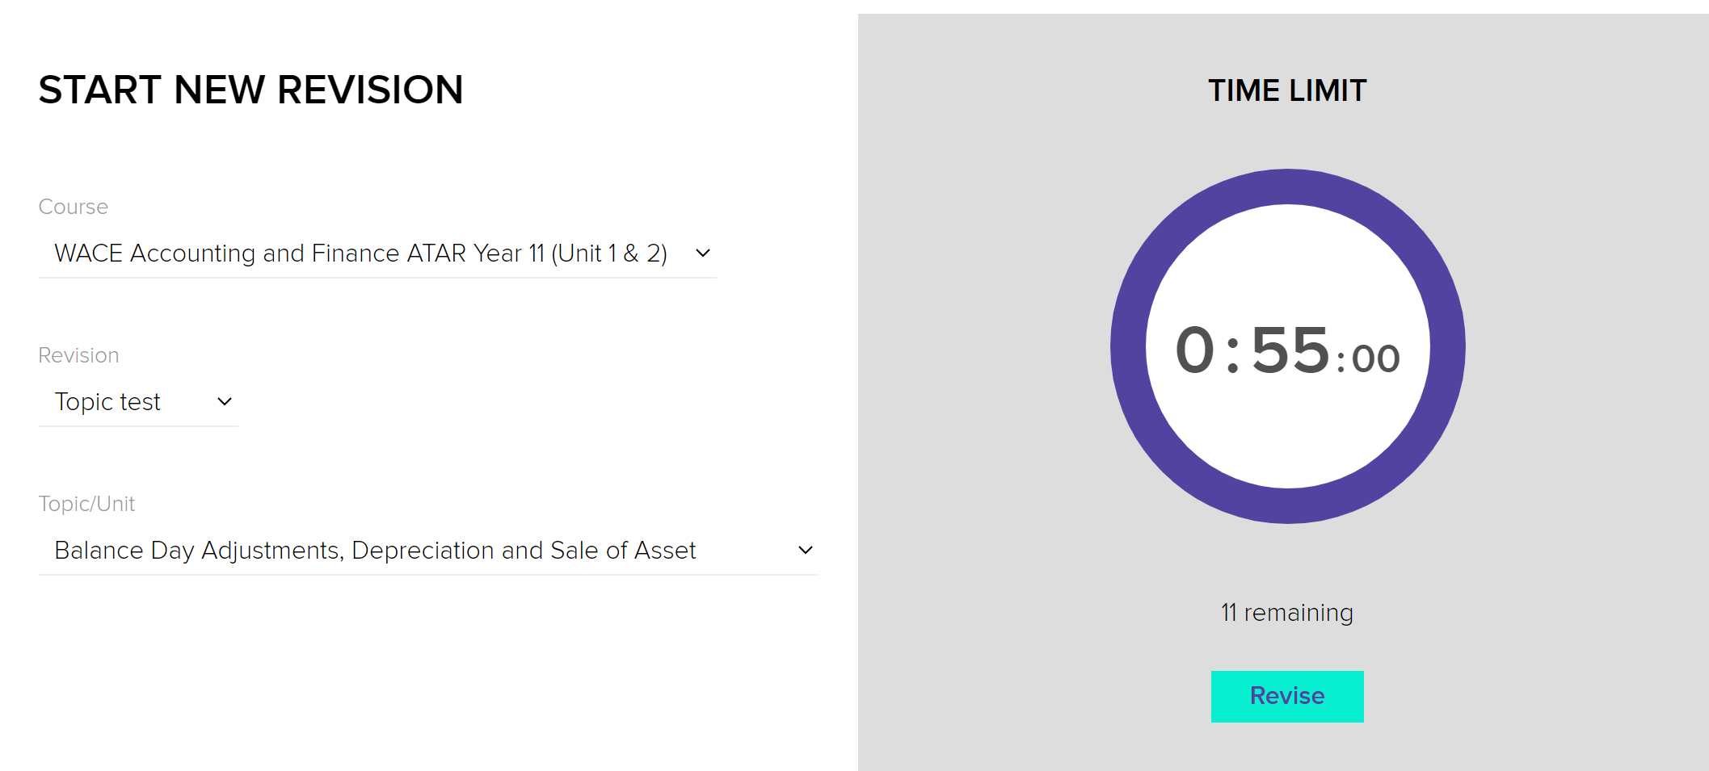

NB: If you don’t like drawing the T-ledgers or journals into the software, do them into your book or document you usually use.